Project Design Phase-II
Data Flow Diagram & User Stories

Date | 31 January 2026
Team ID | LTVIP2026TMIDS52445
Project Name | Prevent User Deletion If Assigned to an Incident in ServiceNow
Maximum Marks | 4 Marks

Data Flow Diagrams:
A Data Flow Diagram (DFD) is a traditional visual representation of the information flows within a system. A neat and clear DFD can depict the right amount of the system requirement graphically. It shows how data enters and leaves the system, what changes the information, and where data is stored.

Example: (Simplified)
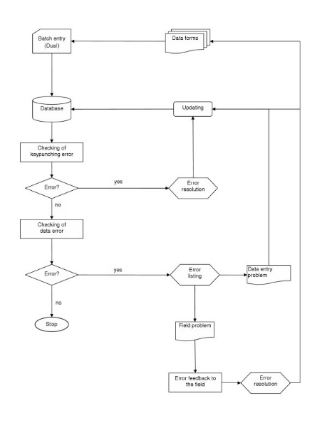

Example: DFD Level 0 (Industry Standard)

External Entity
ServiceNow Admin

Process
User Deletion Validation System

Data Stores
- User Table (sys_user)
- Incident Table (incident)

Data Flow
Admin → Delete User Request → Validation System
Validation System → Check Assigned Incidents → Incident Table
Validation System → Allow / Block Deletion → User Table
Validation System → Error Message → Admi

User Stories
User Type | Functional Requirement (Epic) | User Story Number | User Story / Task | Acceptance Criteria | Priority | Release
Administrator | User Management | USN-1 | As an admin, I want to delete inactive users from the system | User record should be deleted successfully when no incidents are assigned | High | Sprint-1
Administrator | Dependency Validation | USN-2 | As a system, I must check whether the user is assigned to any incident before deletion | System should query the incident table and verify assignment | High | Sprint-1
Administrator | Deletion Restriction | USN-3 | As an admin, I should not be able to delete a user who is assigned to an active incident | Deletion must be blocked with an error message | High | Sprint-1
Administrator | Error Notification | USN-4 | As an admin, I should see a clear error message when deletion is prevented | Error message should display: “User cannot be deleted because they are assigned to incidents” | High | Sprint-1
Administrator | Successful Deletion | USN-5 | As an admin, I should be able to delete users who have no incident assignments | System should allow deletion without errors | High | Sprint-1
Administrator | Performance Optimization | USN-6 | As a system, I should check only the existence of incidents instead of fetching all records | GlideRecord should use setLimit(1) for faster validation | Medium | Sprint-2
Administrator | Active Incident Check | USN-7 | As a system, I should validate only active incidents during deletion check | System should filter incidents where Active = true | Medium | Sprint-2
Administrator | Multi-Table Validation (Future) | USN-8 | As a system, I should check Problem, Change, and Task tables before allowing deletion | Deletion should be blocked if user is assigned in any table | Low | Sprint-3
Administrator | Role-Based Override (Future) | USN-9 | As a super admin, I want permission to override deletion restriction if required | Only users with override role can delete assigned users | Low | Sprint-3

